**Software Project and Process Management**

**Course Project Planning Document**

**——Online Snack Store**

**Team Member**

1853543 黄弋鸥

1852345 毛靖鑫

1853898 谭忠煜

1851350 陈扬森

**1. General View of Project**

**2. Project Initiation and Scope Definition**

**3. Project Planning and Charter**

3.1 Human Organization

3.1.1 Stakeholders

3.2 Activity Planning and Schedules

3.2.1 Work Breakdown Structure (WBS)

3.2.2 Activity List

3.2.3 Critical Path Graph

**4. Risk Management**

**5. Resource Allocation**

5.1 Resource Category

5.2 Identify Resource Requirement

5.3 Resource Scheduling

**6. Monitor and Control**

**7. Project Implementation**

**8. Prototype**

**9. References**

**3. Project Planning and Charter**

**3.1 Human Organization**

This part mainly shows the organization of our group members, their character in our project and the way of communication, that’s how to compose these people together.

**3.1.1 Stakeholders**

|  |  |  |
| --- | --- | --- |
| **Role** | **Name** | **Responsibility** |
| Sponsor | All of us | Sponsor of this project, give request of requirement and change it during comprehension. |
| Project Manager | Huang Yiou | Responsible for monitor development progress, make decision on risk control and resource provision, and ensure software quality. |
| Resource Allocator | Huang Yiou | Responsible for the management of labor, equipment, technical resource. |
| Business Analyst | Chen Yangsen | Responsible for market survey and analysis of our project business cases. |
| Requirements  Analyst | Chen Yangsen | Responsible for communicating requirements with customers, assisting project manager to control and follow up requirement change. |
| Product  Architect | Mao Jingxin | Responsible for the design of the software part of the system structure and model. |
| Product Designer | Mao Jingxin | Responsible for the functional requirements of the project and product design part. |
| Risk Analyst | Tan Zhongyu | Responsible for risk analysis in the process of project. |
| Team Leader | Mao Jingxin | Responsible monitoring and controlling the progress of the project. |
| Team Member | All of us | Development team, responsible for the coding and deployment of the project. |
| Quality Assurance | Tan Zhongyu | Responsible for test cases design, test execution and evaluation of the test execution process. |

**3.2 Activity Planning and Schedules**

This part mainly talks about the activity plan of our project: how to divide our project into part and key activities and how to manage these activities to make best use of our time.

**3.2.1 Work Breakdown Structure (WBS)**

This part we will divide our project into several main parts and figure out the key activities in it.

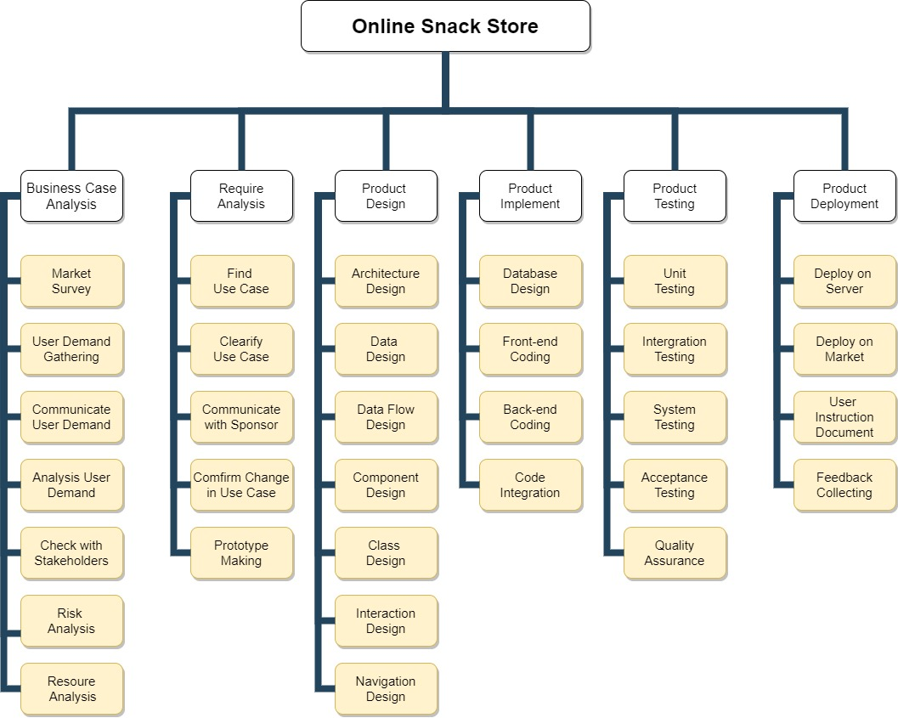

**3.2.2 Activity List**

This part we will figure out the key activities and list them.

|  |  |  |  |
| --- | --- | --- | --- |
| **No.** | **Name** | **Estimated Time (Week)** | **Dependency** |
| A | Business Case Analysis | 1 |  |
| B | Requirement Analysis | 1 | A |
| C | Architecture Design | 1 | B |
| D | Data Design | 1 | B |
| E | Component Design | 2 | B |
| F | Class Design | 2 | B |
| G | Interaction Design | 2 | B |
| H | Back-end Coding | 2 | C,D,E,F |
| I | Front-end Coding | 2 | G |
| J | Test & Quality Assurance | 5 | H,I |
| K | Project Deployment | 1 | K |
| L | Feedback Collecting | 1 | K |

**3.2.3 Critical Path Graph**

Our project will start at March 5th, and end at June 30th according to plan. It will take about 16 weeks.

The follow is the correspondent **Critical Path Graph**.

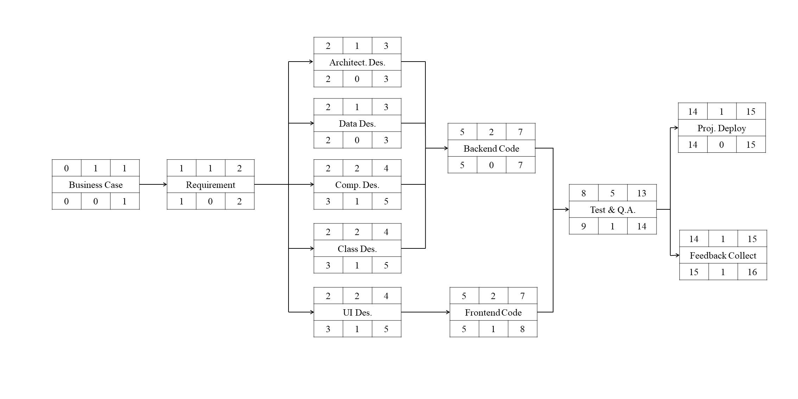

The follow is relevant **Gantt chart**.

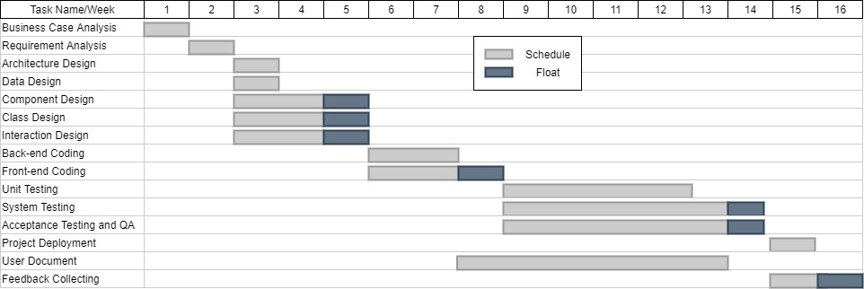

**5. Resource Allocation**

**5.1 Resource Category**

At the first stage of resource allocation part, we should make a resource allocation plan to list all the resources that will be required along with their expected level of demand.

The following table shows the **resource category**.

|  |  |  |
| --- | --- | --- |
| **Res. Category** | **Details** | **Available Resource** |
| Labor | The most important category. It means members of the development project team such as the PM, systems analysts, developers and so on. | Project Manager  Business Analyst  Analyst  Architect  Designer  Team Leader  Team Member  Tester |
| Time | Time is also important and may be short if there are some emergency in our project. | Our project will start at March 5th, and end at June 30th according to plan. It will take about 16 weeks. |
| Space | Space is already available, we conduct our work in our own space when seperated and in a public meeting when together. | Our own workspace  A public meeting room, sometime work online, need one online meeting room |
| Facilities | All basic equipment should be considered. | Laptop  Tables  Chairs  Server to deploy our product |
| Materials | Items that are consumed, rather than equipment that is used. | Disks  Paper |
| Services | Needed service provided by other service developers. | Ali cloud service  Online meeting service |
| Money | Secondary resource, used to buy other resources. | Money for employee, buying equipment, materials and services |

**5.2 Identify Resource Requirement**

The allocation of resources to activities will lead us to review and modify the ideal activity plan. We should revise our project plan after resource allocation.

Firstly we divided our **activity network analysis** into several stages.

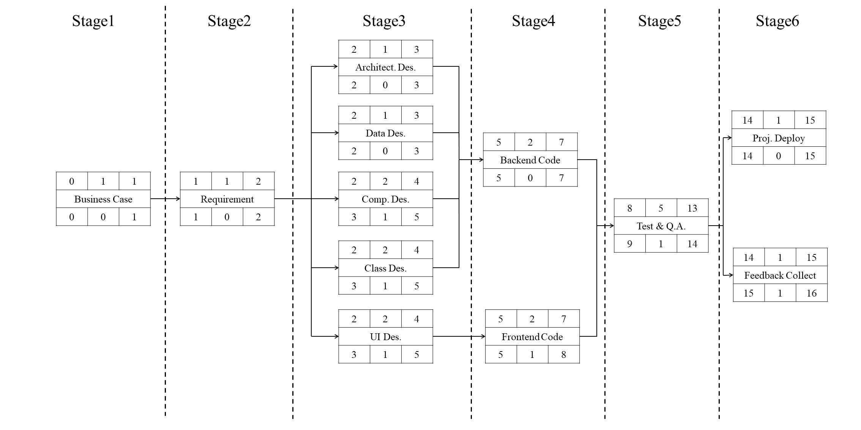

The resource needed in every stage shows in the following **Resource Requirement List**.

|  |  |  |  |  |
| --- | --- | --- | --- | --- |
| **Stage** | **Activities** | **Resource** | **Time** | **Details** |
| 1 | Business case analysis | PM  Business analyst | 1 week | Check business cases. |
| 2 | Requirement analysis | PM  Requirement analyst | 1 week | Analysis of use cases |
| 3 | Architecture design  Data design  Component design  Class design  Interface design | Architect  Team leader  Team member  Meeting room | 3 weeks | Mainly use Analyst/Designer |
| 4 | Backend coding  Frontend coding | Team leader  Team member  Laptops  Work tables & chairs  Meeting room | 3 weeks | most of materials and facilities |
| 5 | Quality Assurance | Tester  Team leader  Team member  Laptops  Work tables & chairs | 5 weeks | mainly test team |
| 6 | Project deployment  Feedback collecting | Team member  Server | 2 weeks | mainly develop team |

**5.3 Resource Scheduling**

The resource schedule shows the dates when each resource will be required and the degree of requirement. It will mainly consider human resource.

The following is the **resource histogram** exported by Gantt chart.

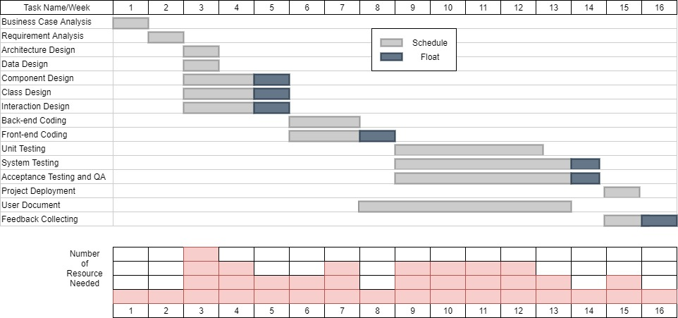

From the above we know every activity has been scheduled to start at its earliest start date, and we assign some float to it. But there is also a question: this scheduling method frequently creates **resource histograms** that start with a peak and then tail off, which is not equal.

So we can adjust the start date of some activities and split other, our **resource histogram** can be smoothed to contain resource demand at available levels. Updated smoothing resource histogram chart is shown below.

